**SEATTLE UNIVERSITY**

**Ghana Living Standard Survey 4**

Final Group Project

*Renato Albolea, Andrew Cardillo, Huy Le, Shuai Ma*

ECON 5100 – 01

Claus Portner

12/10/2018

**Table of Contents**

**1**…………………………………………………………………………………………………………. Title Page

**2**…………………………………………………………………………………………….. Table of Contents

**3**………………………………………………………………………………………….. Executive Summary

**5**……………………………………………………….. Statistical Analysis & Explanation of Steps

**16**…………………………………………………………………………………………………………. Appendix

**Executive Summary - Ghana Living Standard Survey 4**

The following is a summary of our recommendations for ACME’s business exploration into agricultural inputs in Ghana.

Our hypotheses were that education would have a positive impact on profit and that regional differences would have both positive and negative impacts on profit. After analyzing the data, our conclusion is that agricultural profit does not equal higher profit per acre. Additionally, we conclude that farmers who work small- to normal-size farms in the Western, Greater Accra, Volta and Brong Ahafo regions experience higher profit per acre (*Exhibits A, B, and C*).

To increase the effectiveness of our analysis, we divided our dataset into three sections to account for differences between small farms (less than 2 acres), normal farms (2-10 acres) and large farms (10+ acres). Finally, we examined profit per acre to equalize the difference in scale between each farm.

On small- and normal-sized farms, a basic education in the form of a BECE has minimal impact and an advanced education has either no effect or a negative effect on profit *(Exhibits D and E).* On large farms, a BECE is not a significant factor and an advanced education has a negligible positive effect on profitability *(Exhibit F).* We believe that, at 20 households, our sample size of advanced degrees is too small to determine the true impact and that people with higher education are most likely not employed as farmers.

Our results determined that regions have a large impact on profitability per acre for small and normal farms, but no impact on large farms. This is likely because most large farms are in Ashanti, Western and Brong Ahafo, so regional data is limited. For small farms, the most profitable regions are Northern, Western, Greater Accra, Volta and Brong Ahafo. For normal farms, the most profitable regions are Brong Ahafo, Western, Ashanti, Volta, and Greater Accra. Please note that this conclusion does not account for fishing, as fishing is conducted along the coastline and does not contribute to profit per acre.

Other interesting variables we examined include the proximity of motorways, the presence of a bank in the community and the farmer’s quality of life as determined by the quality of materials/construction of their home (e.g. walls and strength of building materials). We assumed that these variables would increase profits per acre as farmers would be able to transport their goods more effectively, utilize financial services and be in better health, respectively. However, our results indicate that these variables either affect profit per acre negatively or we lack evidence that they affect profit per acre in any significant way.

**Exhibit A**

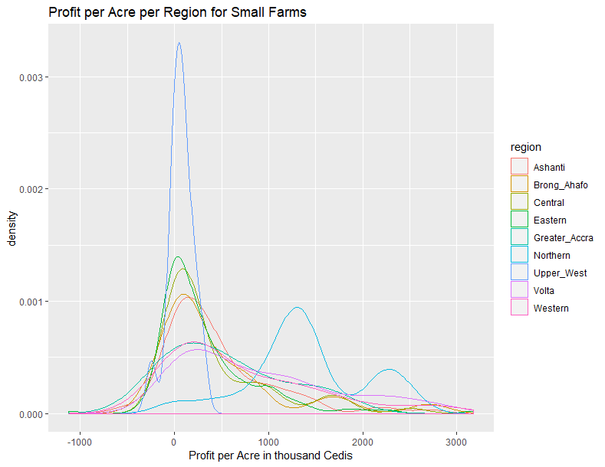

**Exhibit B**

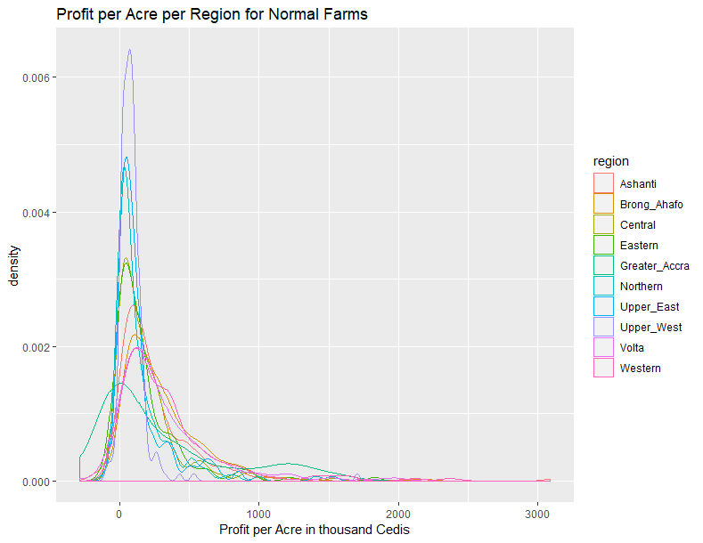

**Exhibit C**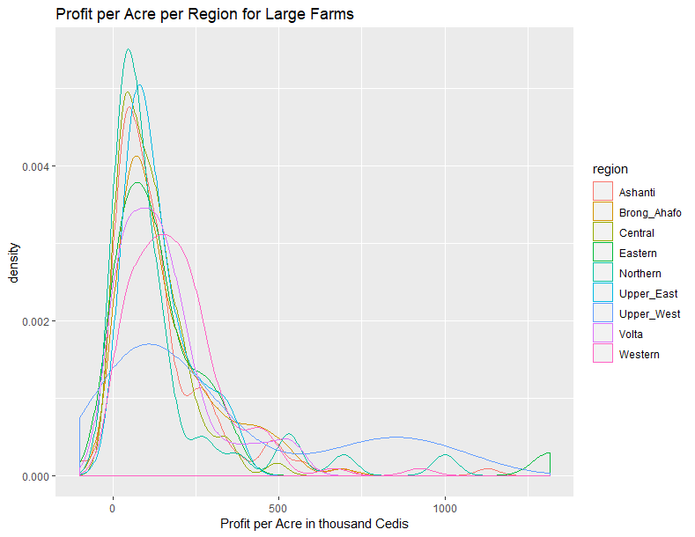

**Exhibit D**

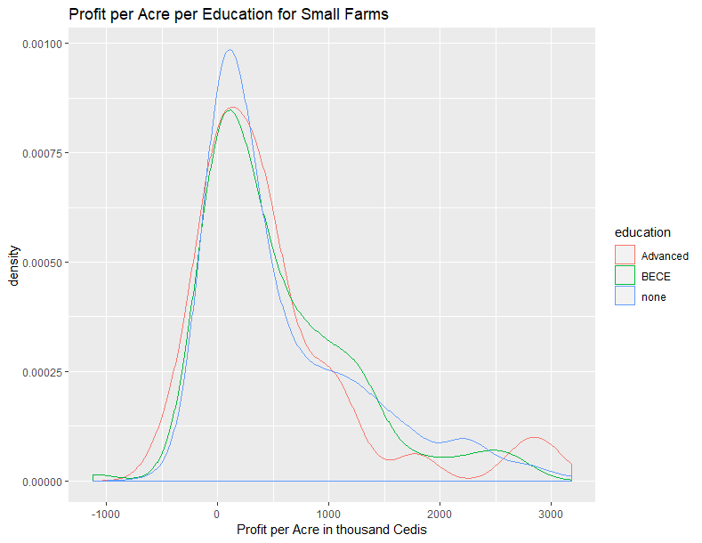

**Exhibit E**

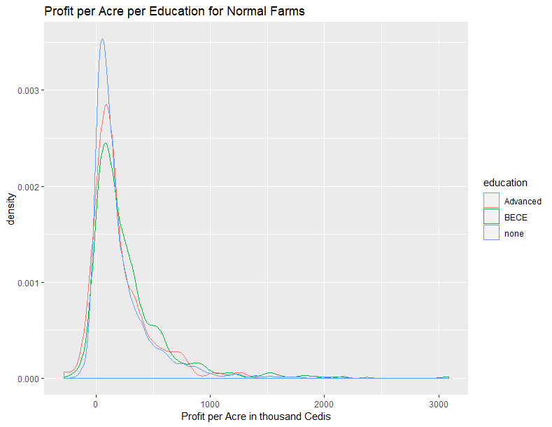

**Exhibit F**

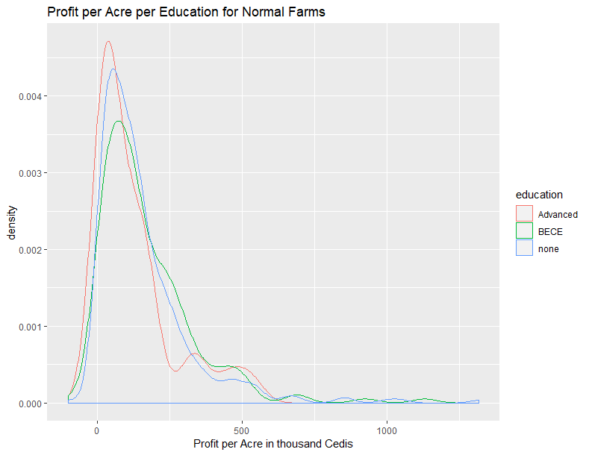

**Statistical Analysis – Ghana Living Standard Survey 4**

**Introduction**

At the start of our work, we set out to answer two questions: first, what variables were most relevant for determining ACME’s potential agricultural profit? Secondly, how did the data/ chosen variables support or discount our hypothesis?

We will now present a walkthrough of the steps we took to evaluate our methods and findings.

**Step 1: Setup HO & Brainstorm Significant Variables**

The first step in our analysis was to import the data, read its associated paperwork and begin brainstorming what variables we believed would be important factors for profit per acre to create our null hypothesis.

Our hypothesis was that 5 factors would have a positive effect on profit: education, region, the presence of motorways, the existence of a bank in the community and the quality of the farmer’s life as determined by the quality of the materials used to build their home. We decided to measure profit per acre to equalize the differences in scale between farm sizes.

**Step 2: Clean & Organize the Dataset**

To clean the data, we began by eliminating outliers (*Appendix A*) and excluding two factors from the dataset – depreciation from profit and instances where profit was equal to 0. This gave us a profit model that we could join our explanatory variables to. We then imported data about household information, land size, farmers, family information, education, workforce and community information and joined these together, excluding certain factors of each category to ensure we would achieve a 97.5% level of significance.

For clarity, we converted Ghanaian units of measurement (poles and ropes) into acres and evaluated each acre according to US dollars. We excluded information about non-farmers, people who own their own businesses, observations that do not have information about education, and communities where fishing accounted for the majority of revenue.

**Step 2: Build Data Model & Identify Significant Variables**

To run our initial analysis, we built a data model to evaluate 55 variables from the Ghana Living Standard Survey 4 that we believed would be significant to profit per acre (*Appendix B*). The first models Standardized Residuals Plot (*Appendix* C) showed a somewhat normally distributed curve with a slight right tail and outliers on the left side, while the Residual vs. Fitted Value scatterplot (*Appendix* D) showed a lot of heteroskedasticity, demonstrating that the variability of our chosen variables was unequal across the range of secondary predictive variables.

We decided to break our data model into three categories to better explain the data. Since the explanatory variables will have different effects across farms of different sizes, we divided our general model to account for three farm sizes: small farms defined as less than 2 acres (*Appendix E*), normal farms defined as 2 – 10 acres (*Appendix H*) and large farms defined as 10+ acres (*Appendix K*) and ran linear regressions of our original variables against them.

**Step 3: Evaluate the Results**

After transforming our data models, we saw immediate improvements in our results. Our new graphs (*Appendixes F, G, I, J, L, and M*) have more normally distributed curves and are closer to homoscedasticity than the first general model, signaling that they are more significant for our profit per acre model. Running linear regression for the 5 variables in our hypothesis produced surprising results – a full table of results for the 58 variables we examined is available for reference as *Appendix*

1. **Education**

We expected that higher levels of education would have a positive effect on farmer’s profit per acre, but the results demonstrate that education has a negligible or even negative effect. From the table below, we can see that having a basic education negatively impacts the profit per acre of a small farm and an advanced education negatively impacts the profit per acre of a normal farm, while each level only marginally affects the profit per acre for all other categories.

All effects are not statistically significant at a level of 95%, so we cannot reject that the variable may have a zero effect on profit.

|  |  |  |  |  |  |  |
| --- | --- | --- | --- | --- | --- | --- |
| **Education** | **Large Farms** | | **Normal Farms** | | **Small Farms** | |
| Estimate | Pr(>|t|) | Estimate | Pr(>|t|) | Estimate | Pr(>|t|) |
| BECE | *0.09* | *.083* | *0.02* | *.298* | ***(0.01)*** | *.584* |
| Advanced | *0.02* | *0.829* | ***(0.05)*** | *.081* | *0.00* | *.971* |

1. **Region**

As expected, region had a wide variety of effects on the profit per acre for each size of farm. Surprisingly, large farms typically see a negative impact of region on their profit per acre. The Western, Greater Accra, Volta and Brong Ahafo regions typically had the most positive effect on profit per margin for normal and small farms, albeit at varying levels of statistical significance.

|  |  |  |  |  |  |  |
| --- | --- | --- | --- | --- | --- | --- |
| **Region** | **Large Farms** | | **Normal Farms** | | **Small Farms** | |
| Estimate | Pr(>|t|) | Estimate | Pr(>|t|) | Estimate | Pr(>|t|) |
| Ashanti | ***(0.20)*** | *0.148* | *0.23* | *2.75E-11* | *0.12* | *0.045* |
| Brong Ahafo | ***(0.11)*** | *0.420* | *0.28* | *1.05E-15* | *0.14* | *0.036* |
| Central | ***(0.32)*** | *0.020* | *0.13* | *0.000119* | *0.10* | *0.109* |
| Eastern | *0.05* | *0.740* | *0.15* | *3.80E-06* | *0.05* | *0.391* |
| Greater Accra | *NA* | *NA* | *0.20* | *0.000126* | *0.16* | *0.041* |
| Northern | ***(0.29)*** | *0.029* | *0.07* | *0.016942* | *0.31* | *1.44E-06* |
| Upper East | ***(0.33)*** | *0.050* | *0.02* | *0.603646* | *NA* | *NA* |
| Volta | ***(0.12)*** | *0.380* | *0.21* | *3.70E-10* | *0.16* | *0.01* |
| Western | ***(0.01)*** | *0.960* | *0.28* | *3.66E-14* | *0.21* | *0.00* |

1. **Presence of Motorways**

In our hypothesis, we assumed that the presence of a motorway would have a positive impact on profit per acre as it would allow farmers to transport their goods to market more efficiently. However, our linear regression shows that there is a negative effect on all three sizes of farms and negligible statistical significance for large and normal farms. This may indicate that motorways are only present in more urban areas where farms are non-existent. As we have no way of determining the exact reason at this time, we suggest exploring the connection in a future analysis.

|  |  |  |  |  |  |  |
| --- | --- | --- | --- | --- | --- | --- |
| **Motorway** | **Large Farms** | | **Normal Farms** | | **Small Farms** | |
| Estimate | Pr(>|t|) | Estimate | Pr(>|t|) | Estimate | Pr(>|t|) |
| ***(0.24)*** | *0.0003* | ***(0.06)*** | *0.008* | ***(0.02)*** | *0.65* |

1. **Bank in the Community**

In our hypothesis, we assumed that the presence of a bank in the community would also provide an advantage for farmers thanks to the availability of financial services, loans, and checking/savings accounts. However, we were again surprised to find that this variable had a negative and statistically insignificant effect on all three farm sizes’ profit per acre. Our reasoning was that farmers in Ghana may not make enough money to justify utilizing a bank, their business does not utilize loans, checking/savings accounts or other types of financial services, or banks are in more urban areas where farms are scarce.

|  |  |  |  |  |  |  |
| --- | --- | --- | --- | --- | --- | --- |
| **Local Bank** | **Large Farms** | | **Normal Farms** | | **Small Farms** | |
| Estimate | Pr(>|t|) | Estimate | Pr(>|t|) | Estimate | Pr(>|t|) |
| ***(0.19)*** | *0.151* | ***(0.12)*** | *0.0008* | ***(0.07)*** | *0.046* |

1. **Farmer’s Quality of Life Determined by Quality of Home**

The fifth variable in our hypothesis was the farmer’s quality of life, which we determined by evaluating the presence of walls and the strength of materials used to build their home (e.g. stone, wood, etc.) and the presence of cooking gas, electricity, a generator, and a flush toilet. For this explanation, we will focus on the materials used to construct the farmer’s house – other variables can be assessed in *Appendix N.*

We were surprised to find that stronger materials such as iron or cement had a negative or negligible effect on profit per acre, and we lack evidence to suggestion that the household construction level bears significance on profit. We conclude that the materials used to build a farmer’s home are not related to how much revenue a farm is generating, perhaps because the materials used during construction are scavenged, donated or otherwise acquired without the need to invest profits from agricultural yields.

|  |  |  |  |  |  |  |
| --- | --- | --- | --- | --- | --- | --- |
| **Wall Material** | **Large Farms** | | **Normal Farms** | | **Small Farms** | |
| Estimate | Pr(>|t|) | Estimate | Pr(>|t|) | Estimate | Pr(>|t|) |
| Cement | *NA* | *NA* | *NA* | *NA* | *NA* | *NA* |
| Iron | *NA* | *NA* | ***(0.24)*** | *0.319* | ***(0.10)*** | *0.395* |
| Mud | ***(0.02)*** | *0.599* | ***(0.02)*** | *0.284* | *0.02* | *0.445* |
| Stone | *0.17* | *.436* | *2.767e03* | *0.962* | *0.06* | *0.494* |
| Wood | ***(0.18)*** | *0.35* | *0.02* | *0.85* | ***(0.06)*** | *0.71* |

1. **Farm Sizes and Age**

The only two continuous variables we used on the model were the age of the head of the household in years and the size of the farm. The best model we found was using a quadratic polynomial regression for both variables.

For the variable “age”, our hypothesis was that the linear factor would show a positive effect and the quadratic component would result in a negative effect, given that young people have less experience but more energy to work and the opposite is true for older people. However, given that both factors (capacity of work and experience) should not change the same amount at the same time, an inflection point should occur. The results of the regression show us that age have almost no effect at all in the profit per acre in cases where it is statistically significant.

For farm size, we anticipated that we should observe an increase in the profitability of the farm with the increase of the land due to scale gains. However, we expected that this would diminish with the increase of the farm because new challenges start to appear with bigger land and due to the exhaustion of some resources with a larger increase.

The model contradicts our hypotheses, showing that the increase of the land has a linear effect of diminishing profitability that is compensated in a small amount by the quadratic increase of the land size. One assumption that may explain this is that farmers probably already work with less resources than the ideal for the size of the farm, so increases of land only make the problem worst.

|  |  |  |  |  |  |  |
| --- | --- | --- | --- | --- | --- | --- |
| **Age & Farm Variables** | **Large Farms** | | **Normal Farms** | | **Small Farms** | |
| Estimate | Pr(>|t|) | Estimate | Pr(>|t|) | Estimate | Pr(>|t|) |
| agey | *0.00* | *0.88* | *0.00* | *0.071* | *0.01* | *0.003* |
| farm_size | ***(0.04)*** | *<2.0E-16* | ***(0.40)*** | *<2.0E-16* | ***(2.40)*** | *<2.0E-16* |
| l(agey^2) | ***(0.00)*** | *0.99* | ***(0.00)*** | *0.049* | *(0.00)* | *0.005* |
| l(farm_size^2) | *0.00* | *2.46E-10* | *0.02* | *<2.0E-16* | *0.65* | *<2.0E-16* |

**Appendix**

1. **Assumptions**

To eliminate outliers, we:

* Excluded farms smaller than .2 acres (16 observations/0.55%)
* Excluded farms larger than 150 acres (10 observations/0.34%)
* Analyzed profit_per_acre only inside 97.5% of confidence interval (62 observations/2.1%)
* Predicted LN of profit_per_acre after scaling up by the minimum observation +10,000
* Excluded communities where fishing is the main activity

**B. General Model Variables & Coefficients**

## Coefficients:

## Estimate Estimate Error t value Pr(>|t|)

## (Intercept) 1.458e+01 1.270e-01 114.783 < 2e-16 ***

01 most_impor_farmingTRUE -1.327e-01 1.028e-01 -1.290 0.197117

02 moto_roadTRUE -3.693e-02 3.732e-02 -0.990 0.322415

03 moto_road_impassableTRUE -3.690e-02 2.257e-02 -1.635 0.102129

04 have_barTRUE -8.494e-03 2.602e-02 -0.326 0.744125

05 have_post_of_pub_telephoneTRUE -6.985e-02 4.305e-02 -1.623 0.104773

06 have_bankTRUE 6.729e-02 5.648e-02 1.191 0.233633

07 have_daily_mktTRUE -6.123e-03 3.710e-02 -0.165 0.868898

08 have_week_mktTRUE -2.744e-02 2.921e-02 -0.939 0.347570

09 public_transpTRUE -4.232e-02 2.723e-02 -1.555 0.120173

10 people_come_for_job_farmingTRUE 4.417e-02 2.577e-02 1.714 0.086616 .

11 have_hospitalTRUE -4.363e-02 9.331e-02 -0.468 0.640158

12 have_agric_ext_centerTRUE 1.727e-02 3.386e-02 0.510 0.610049

13 have_cooperativeTRUE -8.121e-02 2.381e-02 -3.411 0.000657 ***

14 any_farm_use_fertTRUE -1.085e-01 2.442e-02 -4.442 9.28e-06 ***

15 any_farm_use_inset_herbTRUE -1.446e-02 2.799e-02 -0.516 0.605562

16 any_farm_use_irrigateTRUE -3.588e-02 3.939e-02 -0.911 0.362440

17 mutual_aid_farmTRUE 7.658e-02 3.377e-02 2.268 0.023432 *

18 farm_size -1.197e-01 2.121e-03 -56.438 < 2e-16 ***

19 I(farm_size^2) 9.426e-04 2.851e-05 33.067 < 2e-16 ***

20 agey -1.510e-03 7.611e-04 -1.984 0.047353 *

21 spouse_live_hhTRUE 1.303e-02 2.977e-02 0.438 0.661679

22 sex_maleTRUE -1.087e-01 3.294e-02 -3.298 0.000984 ***

23 fishingTRUE 6.041e-02 2.952e-02 2.046 0.040805 *

24 own_businessTRUE -2.840e-02 2.174e-02 -1.306 0.191504

25 educ_beceTRUE -4.255e-02 3.201e-02 -1.329 0.183912

26 educ_advancedTRUE 1.589e-02 4.901e-02 0.324 0.745827

27 do_mathTRUE -1.741e-02 3.204e-02 -0.543 0.586899

28 region_Western 3.895e-01 6.474e-02 6.017 2.01e-09 ***

29 region_Central 1.823e-01 6.189e-02 2.946 0.003244 **

30 region_Greater_Accra 3.102e-01 9.812e-02 3.161 0.001587 **

31 region_Eastern 5.406e-01 5.600e-02 9.654 < 2e-16 ***

32 region_Volta 5.145e-01 5.876e-02 8.756 < 2e-16 ***

33 region_Ashanti 2.819e-01 6.075e-02 4.641 3.63e-06 ***

34 region_Brong_Ahafo 2.566e-01 6.330e-02 4.053 5.19e-05 ***

35 region_Northern 8.274e-02 5.432e-02 1.523 0.127801

36 region_Upper_East -1.448e-01 6.676e-02 -2.170 0.030125 *

37 light_eletricityTRUE 6.133e-03 3.811e-02 0.161 0.872158

38 light_generatorTRUE -1.643e-01 1.337e-01 -1.229 0.219210

39 cooking_full_gasTRUE -5.689e-01 2.863e-01 -1.987 0.047035 *

40 toilet_flushTRUE -2.945e-01 1.378e-01 -2.137 0.032684 *

41 toilet_latrineTRUE -3.768e-02 2.610e-02 -1.444 0.148947

42 wall_mudTRUE 2.723e-03 2.751e-02 0.099 0.921156

43 wall_woodTRUE -2.709e-02 1.626e-01 -0.167 0.867674

44 wall_ironTRUE 2.543e-01 3.089e-01 0.823 0.410430

45 wall_stoneTRUE -1.860e-01 1.059e-01 -1.757 0.079065 .

46 harvest_sold_gateTRUE 1.688e-02 3.961e-02 0.426 0.670039

47 harvest_sold_marketTRUE -7.949e-02 2.243e-02 -3.544 0.000401 ***

48 harvest_sold_consumerTRUE 3.073e-02 3.764e-02 0.817 0.414241

49 harvest_sold_state_orgTRUE 3.600e-02 2.945e-02 1.223 0.221560

50 harvest_sold_coopTRUE 1.850e-01 1.086e-01 1.704 0.088438 .

51 paid_at_saleTRUE -3.419e-02 2.211e-01 -0.155 0.877121

52 paid_at_weekTRUE -2.862e-01 2.229e-01 -1.284 0.199390

53 paid_at_monthTRUE -1.264e-01 1.912e-01 -0.661 0.508608

54 males_on_farme 1.412e-03 1.393e-03 1.014 0.310810

55 females_on_farme -1.081e-03 2.598e-03 -0.416 0.677203

## ---

## Signif. codes: 0 '***' 0.001 '**' 0.01 '*' 0.05 '.' 0.1 ' ' 1

##

## Residual standard error: 0.528 on 2813 degrees of freedom

## Multiple R-squared: 0.6869, Adjusted R-squared: 0.6808

## F-statistic: 112.2 on 55 and 2813 DF, p-value: < 2.2e-16

1. **Standardized Residuals Plot (General Model)**

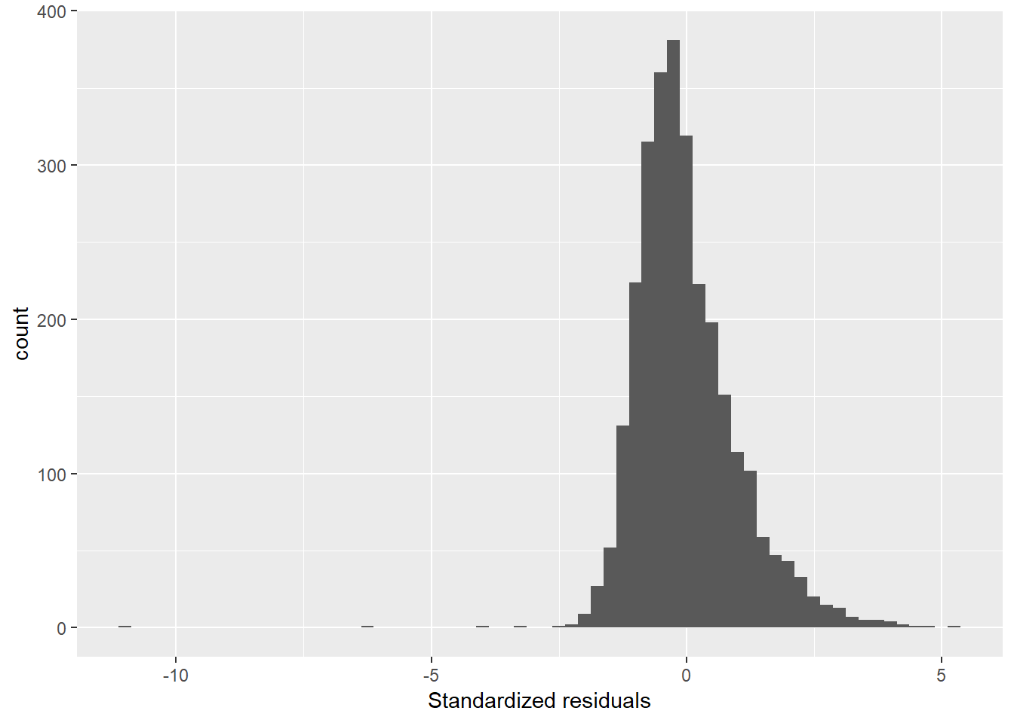

1. **Residual vs. Fitted Value (General Model)**

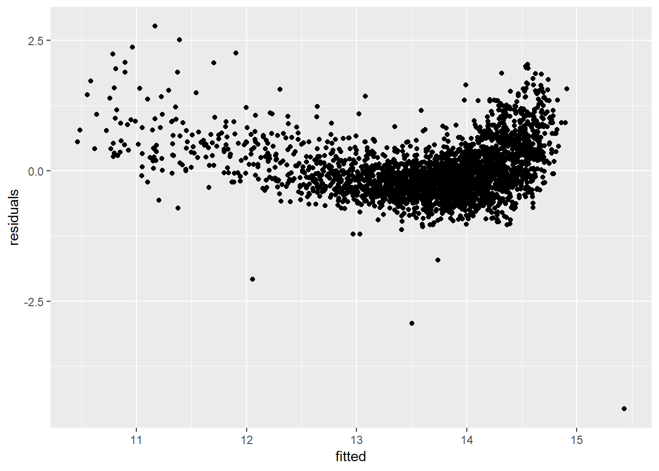

1. **Small Farm Model Variables & Coefficients (<2 Acres – 496 Observations)**

## Coefficients: (8 not defined because of singularities)

## Estimate Estimate Error t value Pr(>|t|)

## (Intercept) 1.643e+01 1.182e-01 139.017 < 2e-16 ***

1 most_impor_farmingTRUE -1.922e-02 5.616e-02 -0.342 0.732301

2 most_impor_fishingTRUE NA NA NA NA

3 moto_roadTRUE -1.843e-02 4.009e-02 -0.460 0.645898

4 moto_road_impassableTRUE 2.408e-02 1.994e-02 1.207 0.227940

5 have_barTRUE -1.398e-02 2.113e-02 -0.661 0.508652

6 have_post_of_pub_telephoneTRUE 1.331e-03 3.515e-02 0.038 0.969822

7 have_bankTRUE -7.120e-02 3.556e-02 -2.003 0.045834 *

8 have_daily_mktTRUE -1.269e-03 3.207e-02 -0.040 0.968446

9 have_week_mktTRUE 2.166e-03 2.470e-02 0.088 0.930169

10 public_transpTRUE -1.756e-02 2.154e-02 -0.815 0.415399

11 people_come_for_job_farmingTRUE 4.258e-03 1.840e-02 0.231 0.817140

12 have_hospitalTRUE 6.383e-02 8.009e-02 0.797 0.425893

13 have_agric_ext_centerTRUE 6.734e-03 2.699e-02 0.249 0.803106

14 have_cooperativeTRUE -2.553e-02 1.975e-02 -1.293 0.196765

15 any_farm_use_fertTRUE -3.114e-02 1.955e-02 -1.593 0.111802

16 any_farm_use_inset_herbTRUE -7.986e-03 2.238e-02 -0.357 0.721410

17 any_farm_use_irrigateTRUE -2.337e-02 2.741e-02 -0.853 0.394230

18 mutual_aid_farmTRUE 1.736e-02 2.585e-02 0.672 0.502177

19 farm_size -2.399e+00 8.467e-02 -28.337 < 2e-16 ***

20 I(farm_size^2) 6.474e-01 4.026e-02 16.079 < 2e-16 ***

21 agey 8.013e-03 2.723e-03 2.943 0.003421 **

22 I(agey^2) -7.544e-05 2.673e-05 -2.822 0.004980 **

23 spouse_live_hhTRUE 5.832e-02 2.197e-02 2.655 0.008219 **

24 sex_maleTRUE -2.977e-02 2.260e-02 -1.317 0.188464

25 fishingTRUE 4.360e-02 2.454e-02 1.776 0.076340 .

26 own_businessTRUE -3.655e-03 1.590e-02 -0.230 0.818314

27 educ_beceTRUE -1.319e-02 2.407e-02 -0.548 0.583985

28 educ_advancedTRUE 1.290e-03 3.496e-02 0.037 0.970578

29 do_mathTRUE 2.139e-02 2.269e-02 0.943 0.346209

30 region_Western 2.131e-01 6.117e-02 3.483 0.000545 ***

31 region_Central 9.732e-02 6.064e-02 1.605 0.109220

32 region_Greater_Accra 1.567e-01 7.644e-02 2.050 0.040930 *

33 region_Eastern 4.551e-02 5.306e-02 0.858 0.391493

34 region_Volta 1.557e-01 5.651e-02 2.754 0.006122 **

35 region_Ashanti 1.217e-01 6.070e-02 2.006 0.045498 *

36 region_Brong_Ahafo 1.444e-01 6.859e-02 2.106 0.035793 *

37 region_Northern 3.075e-01 6.294e-02 4.886 1.44e-06 ***

38 region_Upper_East NA NA NA NA

39 light_eletricityTRUE -6.210e-03 2.728e-02 -0.228 0.820061

40 light_generatorTRUE NA NA NA NA

41 cooking_full_gasTRUE NA NA NA NA

42 toilet_flushTRUE 2.244e-02 1.005e-01 0.223 0.823423

43 toilet_latrineTRUE 1.997e-02 1.835e-02 1.088 0.277171

44 wall_mudTRUE 1.657e-02 2.167e-02 0.765 0.444936

45 wall_woodTRUE -6.315e-02 1.695e-01 -0.373 0.709646

46 wall_ironTRUE -1.046e-01 1.229e-01 -0.851 0.395225

47 wall_stoneTRUE 5.897e-02 8.606e-02 0.685 0.493541

48 wall_cementTRUE NA NA NA NA

49 harvest_sold_gateTRUE 7.818e-02 3.357e-02 2.329 0.020328 *

50 harvest_sold_marketTRUE 6.186e-02 1.771e-02 3.493 0.000526 ***

51 harvest_sold_consumerTRUE 1.378e-02 3.068e-02 0.449 0.653583

52 harvest_sold_state_orgTRUE 9.857e-02 2.747e-02 3.588 0.000370 ***

53 harvest_sold_coopTRUE NA NA NA NA

54 paid_at_saleTRUE NA NA NA NA

55 paid_at_weekTRUE NA NA NA NA

56 paid_at_monthTRUE 1.723e-01 1.712e-01 1.007 0.314681

57 males_on_farme -6.061e-04 3.144e-03 -0.193 0.847217

58 females_on_farme 4.739e-03 2.296e-03 2.064 0.039552 *

## ---

## Signif. codes: 0 '***' 0.001 '**' 0.01 '*' 0.05 '.' 0.1 ' ' 1

##

## Residual standard error: 0.1608 on 445 degrees of freedom

## Multiple R-squared: 0.9055, Adjusted R-squared: 0.8948

## F-statistic: 85.24 on 50 and 445 DF, p-value: < 2.2e-16

1. **Standardized Residuals Plot (Small Farm Model)**

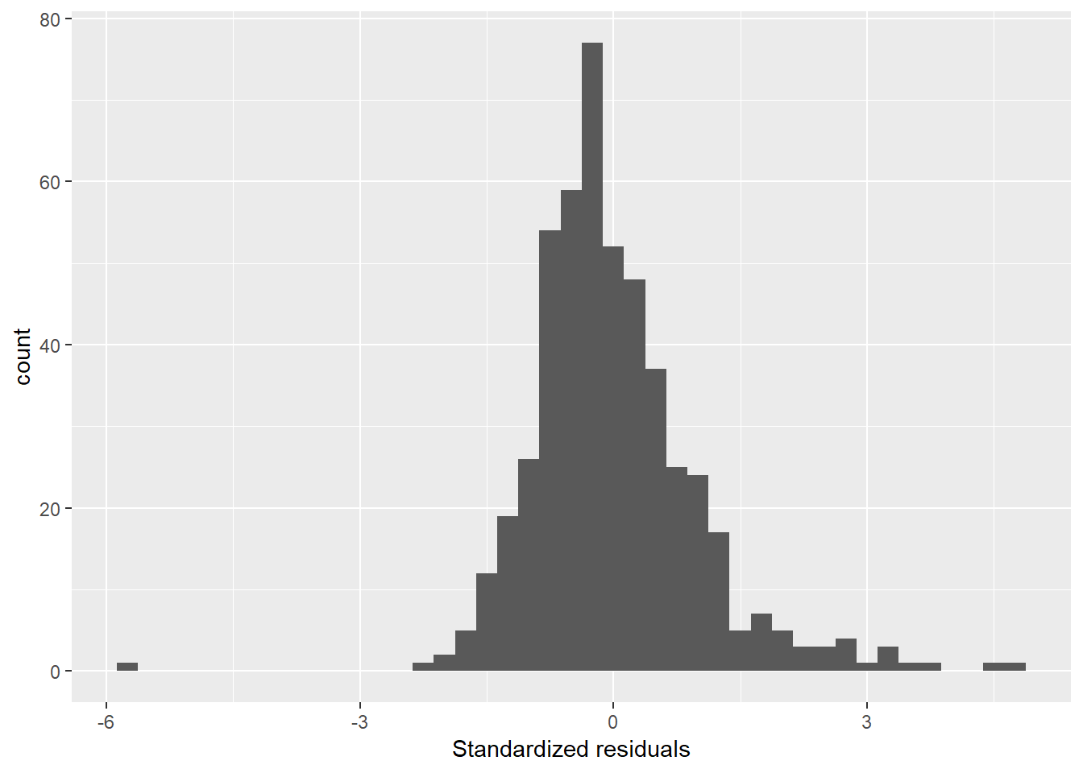

1. **Residuals vs. Fitted Values Plot (Small Farm Model)**

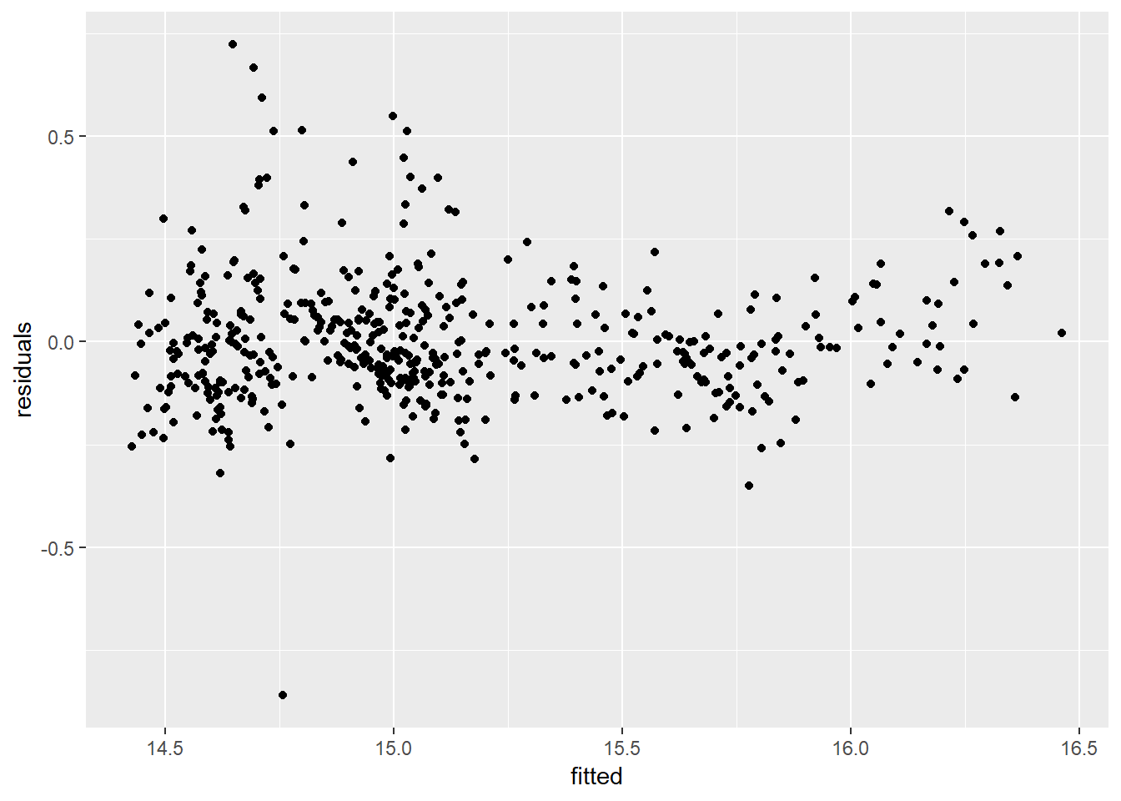

1. **Model for Normal Farm Variables & Coefficients (2 – 10 Acres, 1787 Observations)**

## Coefficients: (2 not defined because of singularities)

## Estimate Estimate Error t value Pr(>|t|)

## (Intercept) 1.481e+01 9.719e-02 152.341 < 2e-16 ***

1 most_impor_farmingTRUE -1.834e-02 6.633e-02 -0.277 0.782168

2 most_impor_fishingTRUE NA NA NA NA

3 moto_roadTRUE -5.503e-02 2.081e-02 -2.645 0.008249 **

04 moto_road_impassableTRUE -1.915e-02 1.283e-02 -1.493 0.135696

05 have_barTRUE 1.898e-03 1.539e-02 0.123 0.901855

06 have_post_of_pub_telephoneTRUE 4.779e-02 2.409e-02 1.983 0.047481 *

07 have_bankTRUE -1.160e-01 3.459e-02 -3.353 0.000817 ***

08 have_daily_mktTRUE -3.135e-02 2.088e-02 -1.501 0.133533

09 have_week_mktTRUE -7.948e-03 1.639e-02 -0.485 0.627768

10 public_transpTRUE -2.801e-02 1.597e-02 -1.754 0.079616 .

11 people_come_for_job_farmingTRUE -9.357e-03 1.513e-02 -0.619 0.536325

12 have_hospitalTRUE 5.969e-02 5.504e-02 1.085 0.278254

13 have_agric_ext_centerTRUE 2.745e-02 1.937e-02 1.417 0.156605

14 have_cooperativeTRUE -3.433e-02 1.378e-02 -2.491 0.012844 *

15 any_farm_use_fertTRUE -3.969e-02 1.444e-02 -2.749 0.006048 **

16 any_farm_use_inset_herbTRUE 7.205e-03 1.606e-02 0.449 0.653773

17 any_farm_use_irrigateTRUE -2.466e-02 2.309e-02 -1.068 0.285661

18 mutual_aid_farmTRUE 3.942e-02 2.025e-02 1.947 0.051702 .

19 farm_size -4.016e-01 1.221e-02 -32.904 < 2e-16 ***

20 I(farm_size^2) 1.965e-02 1.056e-03 18.608 < 2e-16 ***

21 agey 4.210e-03 2.330e-03 1.807 0.070965 .

22 I(agey^2) -4.549e-05 2.313e-05 -1.967 0.049400 *

23 spouse_live_hhTRUE 7.370e-02 1.732e-02 4.255 2.20e-05 ***

24 sex_maleTRUE -2.935e-02 1.930e-02 -1.521 0.128534

25 fishingTRUE 5.045e-02 1.704e-02 2.960 0.003113 **

26 own_businessTRUE -2.604e-02 1.256e-02 -2.074 0.038267 *

27 educ_beceTRUE 1.974e-02 1.898e-02 1.040 0.298551

28 educ_advancedTRUE -5.130e-02 2.940e-02 -1.745 0.081192 .

29 do_mathTRUE -1.644e-02 1.917e-02 -0.858 0.391111

30 region_Western 2.846e-01 3.726e-02 7.637 3.66e-14 ***

31 region_Central 1.337e-01 3.466e-02 3.857 0.000119 ***

32 region_Greater_Accra 2.011e-01 5.232e-02 3.843 0.000126 ***

33 region_Eastern 1.504e-01 3.243e-02 4.637 3.80e-06 ***

34 region_Volta 2.094e-01 3.322e-02 6.303 3.70e-10 ***

35 region_Ashanti 2.289e-01 3.414e-02 6.704 2.75e-11 ***

36 region_Brong_Ahafo 2.849e-01 3.519e-02 8.098 1.05e-15 ***

37 region_Northern 6.859e-02 2.870e-02 2.390 0.016942 *

38 region_Upper_East 1.707e-02 3.288e-02 0.519 0.603646

39 light_eletricityTRUE -1.580e-02 2.222e-02 -0.711 0.477008

40 light_generatorTRUE 4.669e-02 6.999e-02 0.667 0.504776

41 cooking_full_gasTRUE -2.527e-01 1.497e-01 -1.688 0.091573 .

42 toilet_flushTRUE -1.908e-02 7.971e-02 -0.239 0.810818

43 toilet_latrineTRUE -5.051e-03 1.543e-02 -0.327 0.743402

44 wall_mudTRUE -1.725e-02 1.611e-02 -1.071 0.284334

45 wall_woodTRUE 2.060e-02 1.088e-01 0.189 0.849832

46 wall_ironTRUE -2.399e-01 2.406e-01 -0.997 0.318865

47 wall_stoneTRUE 2.767e-03 5.853e-02 0.047 0.962297

48 wall_cementTRUE NA NA NA NA

49 harvest_sold_gateTRUE 8.066e-02 2.301e-02 3.505 0.000469 ***

50 harvest_sold_marketTRUE 7.487e-02 1.310e-02 5.715 1.29e-08 ***

51 harvest_sold_consumerTRUE 5.514e-02 2.261e-02 2.439 0.014840 *

52 harvest_sold_state_orgTRUE 1.327e-01 1.818e-02 7.300 4.37e-13 ***

53 harvest_sold_coopTRUE 1.034e-01 8.251e-02 1.253 0.210410

54 paid_at_saleTRUE 1.646e-01 1.104e-01 1.490 0.136306

55 paid_at_weekTRUE -8.284e-02 1.027e-01 -0.807 0.419871

56 paid_at_monthTRUE -2.874e-02 1.243e-01 -0.231 0.817122

57 males_on_farme 7.361e-04 1.429e-03 0.515 0.606611

58 females_on_farme 8.106e-04 2.036e-03 0.398 0.690648

## Signif. codes: 0 '***' 0.001 '**' 0.01 '*' 0.05 '.' 0.1 ' ' 1

##

## Residual standard error: 0.2383 on 1730 degrees of freedom

## Multiple R-squared: 0.7669, Adjusted R-squared: 0.7594

## F-statistic: 101.7 on 56 and 1730 DF, p-value: < 2.2e-16

1. **Standardized Residuals Plot (Normal Farm Model)**

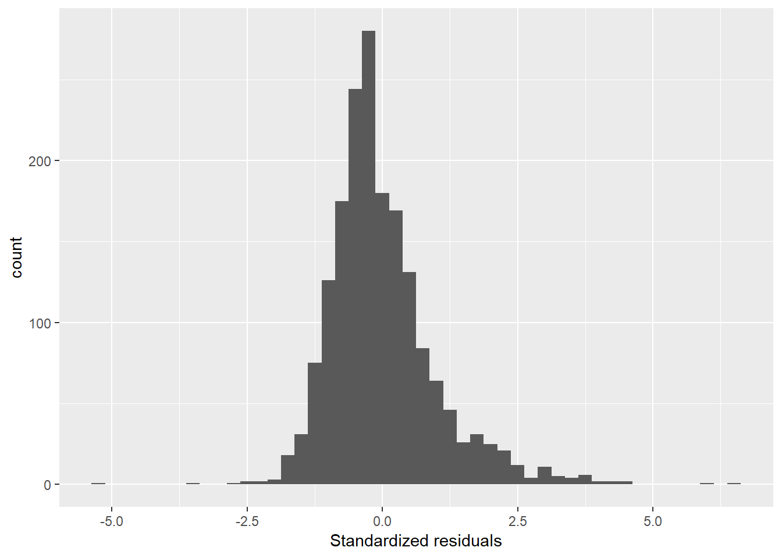

1. **Residual vs. Fitted Value Plot (Normal Farm Model)**

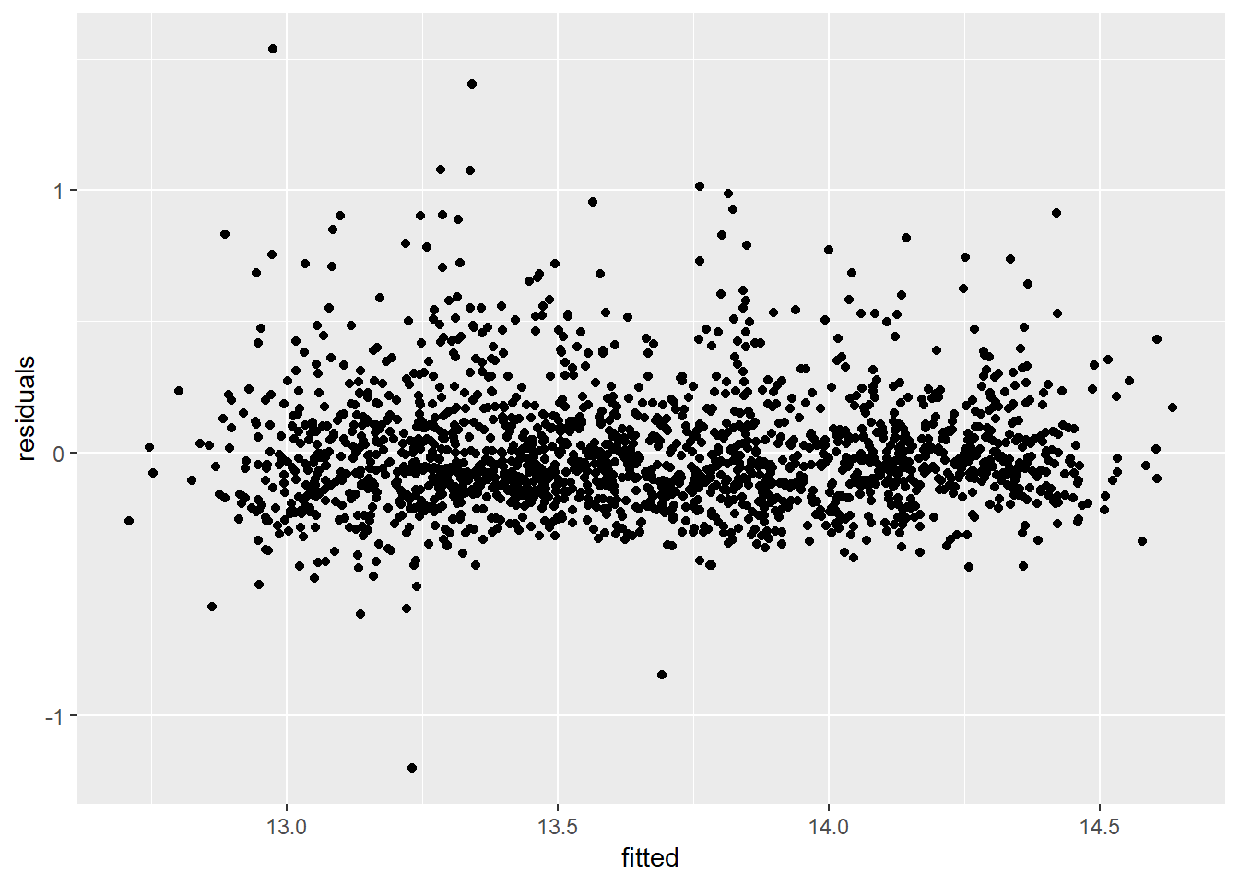

1. **Large Farm Model Variables & Coefficients (10+ Acres – 496 Observations)**

## Coefficients: (5 not defined because of singularities)

## Estimate Estimate Error t value Pr(>|t|)

## (Intercept) 1.336e+01 3.148e-01 42.441 < 2e-16 ***

01 most_impor_farmingTRUE 8.398e-02 2.217e-01 0.379 0.705038

02 most_impor_fishingTRUE NA NA NA NA

03 moto_roadTRUE -2.400e-01 6.596e-02 -3.638 0.000301 ***

04 moto_road_impassableTRUE -1.469e-01 4.216e-02 -3.485 0.000534 ***

05 have_barTRUE -5.318e-02 4.555e-02 -1.167 0.243567

06 have_post_of_pub_telephoneTRUE 6.455e-02 9.483e-02 0.681 0.496381

07 have_bankTRUE -1.869e-01 1.300e-01 -1.437 0.151212

08 have_daily_mktTRUE 5.518e-02 6.988e-02 0.790 0.430100

09 have_week_mktTRUE -1.289e-01 5.897e-02 -2.185 0.029308 *

10 public_transpTRUE 1.193e-03 5.125e-02 0.023 0.981437

11 people_come_for_job_farmingTRUE 9.096e-02 5.081e-02 1.790 0.073997 .

12 have_hospitalTRUE -1.661e-01 1.562e-01 -1.063 0.288154

13 have_agric_ext_centerTRUE -5.371e-02 6.499e-02 -0.826 0.408958

14 have_cooperativeTRUE -1.193e-01 4.034e-02 -2.958 0.003232 **

15 any_farm_use_fertTRUE -1.373e-02 4.254e-02 -0.323 0.746903

16 any_farm_use_inset_herbTRUE 2.506e-02 5.477e-02 0.457 0.647535

17 any_farm_use_irrigateTRUE -1.395e-01 8.654e-02 -1.611 0.107664

18 mutual_aid_farmTRUE 1.554e-01 6.098e-02 2.548 0.011111 *

19 farm_size -4.350e-02 3.197e-03 -13.609 < 2e-16 ***

20 I(farm_size^2) 2.097e-04 3.249e-05 6.453 2.46e-10 ***

21 agey 1.087e-03 7.186e-03 0.151 0.879785

22 I(agey^2) -8.232e-07 6.768e-05 -0.012 0.990300

23 spouse_live_hhTRUE 7.013e-02 5.479e-02 1.280 0.201159

24 sex_maleTRUE -6.617e-03 6.505e-02 -0.102 0.919020

25 fishingTRUE 8.599e-02 5.127e-02 1.677 0.094106 .

26 own_businessTRUE 4.701e-02 3.930e-02 1.196 0.232122

27 educ_beceTRUE 9.002e-02 5.193e-02 1.734 0.083568 .

28 educ_advancedTRUE 1.717e-02 7.955e-02 0.216 0.829174

29 do_mathTRUE -5.596e-02 5.242e-02 -1.068 0.286200

30 region_Western -6.960e-03 1.378e-01 -0.050 0.959748

31 region_Central -3.242e-01 1.394e-01 -2.325 0.020430 *

32 region_Greater_Accra NA NA NA NA

33 region_Eastern 4.823e-02 1.454e-01 0.332 0.740281

34 region_Volta -1.199e-01 1.365e-01 -0.878 0.380189

35 region_Ashanti -1.957e-01 1.351e-01 -1.449 0.147980

36 region_Brong_Ahafo -1.089e-01 1.349e-01 -0.807 0.419900

37 region_Northern -2.854e-01 1.302e-01 -2.192 0.028845 *

38 region_Upper_East -3.290e-01 1.671e-01 -1.969 0.049512 *

39 light_eletricityTRUE -2.157e-02 7.286e-02 -0.296 0.767352

40 light_generatorTRUE 1.302e-02 2.106e-01 0.062 0.950723

41 cooking_full_gasTRUE -1.841e-01 4.791e-01 -0.384 0.700927

42 toilet_flushTRUE -2.392e-01 2.495e-01 -0.959 0.338134

43 toilet_latrineTRUE -1.491e-01 4.784e-02 -3.117 0.001924 **

44 wall_mudTRUE -2.406e-02 4.572e-02 -0.526 0.598958

45 wall_woodTRUE -1.761e-01 1.882e-01 -0.935 0.349999

46 wall_ironTRUE NA NA NA NA

47 wall_stoneTRUE 1.659e-01 2.126e-01 0.780 0.435525

48 wall_cementTRUE NA NA NA NA

49 harvest_sold_gateTRUE 1.429e-01 7.190e-02 1.987 0.047385 *

50 harvest_sold_marketTRUE 1.031e-01 3.983e-02 2.589 0.009877 **

51 harvest_sold_consumerTRUE 1.511e-01 5.668e-02 2.666 0.007911 **

52 harvest_sold_state_orgTRUE 1.626e-01 4.300e-02 3.781 0.000174 ***

53 harvest_sold_coopTRUE 2.475e-01 1.154e-01 2.145 0.032413 *

54 paid_at_saleTRUE -6.229e-01 4.121e-01 -1.512 0.131243

55 paid_at_weekTRUE NA NA NA NA

56 paid_at_monthTRUE -1.794e-01 2.373e-01 -0.756 0.450013

57 males_on_farme 1.271e-03 1.232e-03 1.032 0.302515

58 females_on_farme -5.420e-04 2.870e-03 -0.189 0.850267

## Signif. codes: 0 '***' 0.001 '**' 0.01 '*' 0.05 '.' 0.1 ' ' 1

##

## Residual standard error: 0.3981 on 532 degrees of freedom

## Multiple R-squared: 0.5629, Adjusted R-squared: 0.5193

## F-statistic: 12.93 on 53 and 532 DF, p-value: < 2.2e-16

1. **Standardized Residuals Plot (Large Farm Model)**

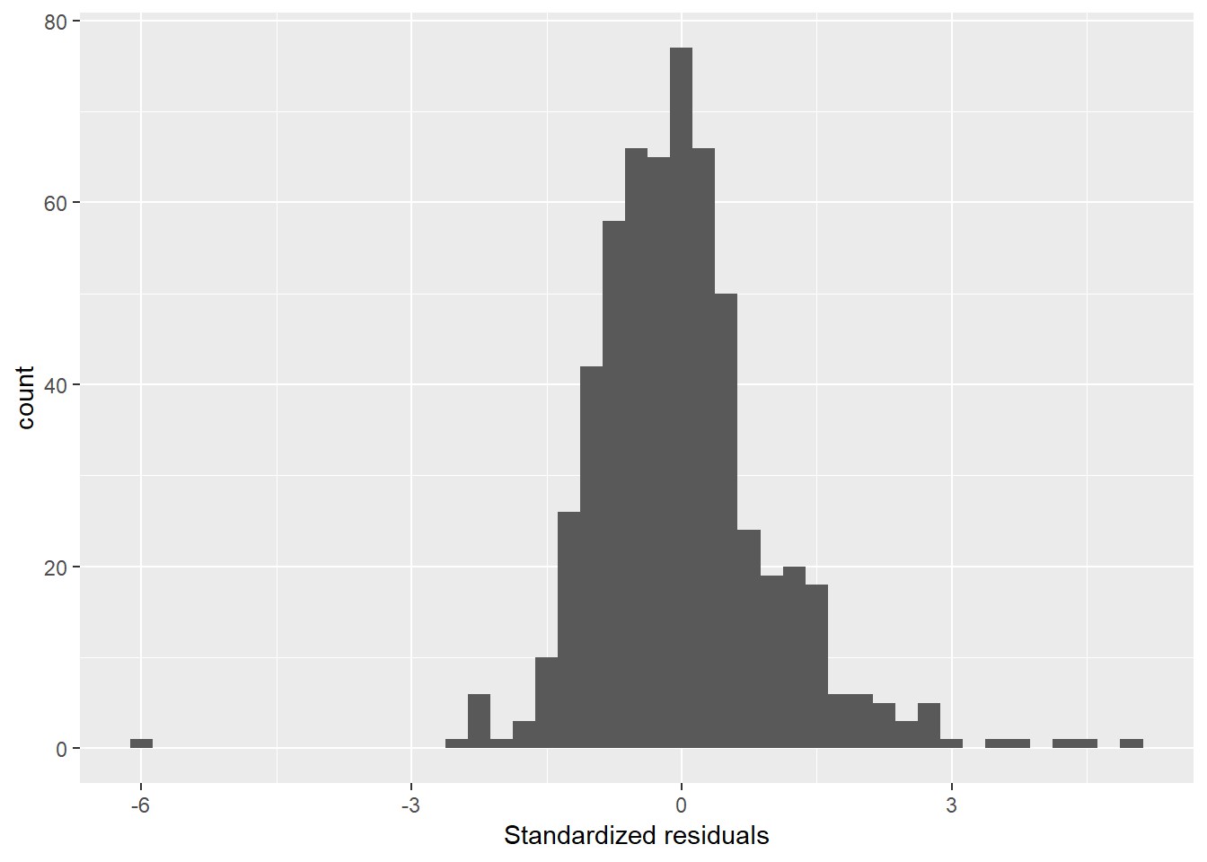

1. **Residuals vs. Fitted Values Plot (Large Farm Model)**

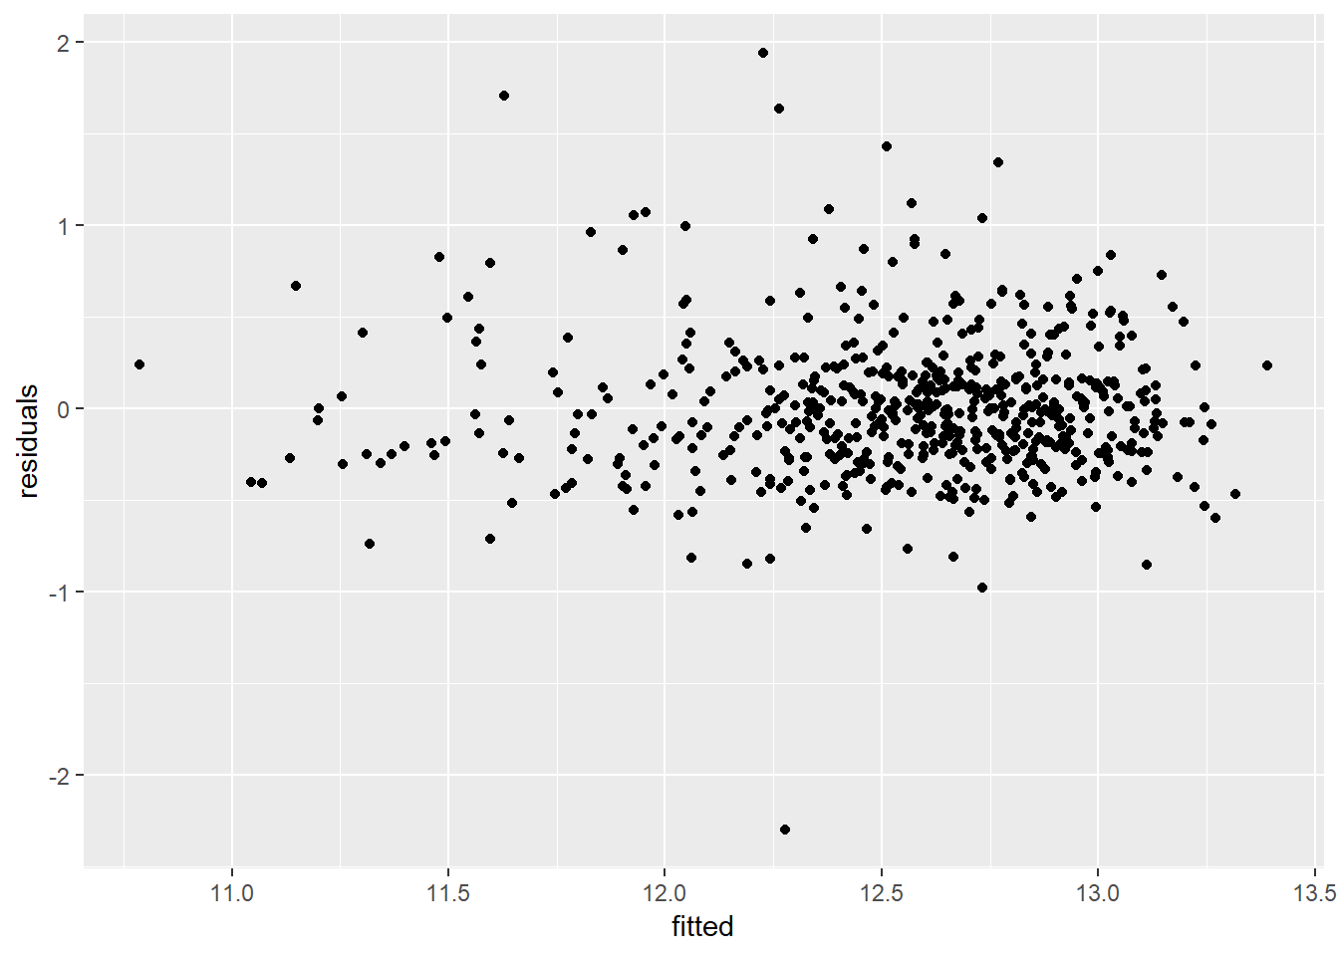

1. **Linear Regression Results for All 58 Variables**

|  |  |  |  |  |  |  |
| --- | --- | --- | --- | --- | --- | --- |
|  | **Large Farms** | | **Normal Farms** | | **Small Farms** | |
|  | Estimate | Pr(>|t|) | Estimate | Pr(<|t|) | Estimate | Pr(>|t|) |
| (Intercept) | 13.36 | < | 14.81 | < | 16.43 | < |
| agey | 0.00 | 0.879785 | 0.00 | 0.070965 | 0.01 | 0.003421 |
| any_farm_use_fertTRUE | (0.01) | 0.746903 | (0.04) | 0.006048 | (0.03) | 0.111802 |
| any_farm_use_inset_herbTRUE | 0.03 | 0.647535 | 0.01 | 0.653773 | (0.01) | 0.72141 |
| any_farm_use_irrigateTRUE | (0.14) | 0.107664 | (0.02) | 0.285661 | (0.02) | 0.39423 |
| cooking_full_gasTRUE | (0.18) | 0.700927 | (0.25) | 0.091573 | NA | NA |
| do_mathTRUE | (0.06) | 0.2862 | (0.02) | 0.391111 | 0.02 | 0.346209 |
| educ_advancedTRUE | 0.02 | 0.829174 | (0.05) | 0.081192 | 0.00 | 0.970578 |
| educ_beceTRUE | 0.09 | 0.083568 | 0.02 | 0.298551 | (0.01) | 0.583985 |
| farm_size | (0.04) | <2.00E-16 | (0.40) | <2.00E-16 | (2.40) | <2.00E-16 |
| females_on_farme | (0.00) | 0.850267 | 0.00 | 0.690648 | 0.00 | 0.039552 |
| fishingTRUE | 0.09 | 0.094106 | 0.05 | 0.003113 | 0.04 | 0.07634 |
| harvest_sold_consumerTRUE | 0.15 | 0.007911 | 0.06 | 0.01484 | 0.01 | 0.653583 |
| harvest_sold_coopTRUE | 0.25 | 0.032413 | 0.10 | 0.21041 | NA | NA |
| harvest_sold_gateTRUE | 0.14 | 0.047385 | 0.08 | 0.000469 | 0.08 | 0.020328 |
| harvest_sold_marketTRUE | 0.10 | 0.009877 | 0.07 | 1.29E-08 | 0.06 | 0.000526 |
| harvest_sold_state_orgTRUE | 0.16 | 0.000174 | 0.13 | 4.37E-13 | 0.10 | 0.00037 |
| have_agric_ext_centerTRUE | (0.05) | 0.408958 | 0.03 | 0.156605 | 0.01 | 0.803106 |
| have_bankTRUE | (0.19) | 0.151212 | (0.12) | 0.000817 | (0.07) | 0.045834 |
| have_barTRUE | (0.05) | 0.243567 | 0.00 | 0.901855 | (0.01) | 0.508652 |
| have_cooperativeTRUE | (0.12) | 0.003232 | (0.03) | 0.012844 | (0.03) | 0.196765 |
| have_daily_mktTRUE | 0.06 | 0.4301 | (0.03) | 0.133533 | (0.00) | 0.968446 |
| have_hospitalTRUE | (0.17) | 0.288154 | 0.06 | 0.278254 | 0.06 | 0.425893 |
| have_post_of_pub_telephoneTRUE | 0.06 | 0.496381 | 0.05 | 0.047481 | 0.00 | 0.969822 |
| have_week_mktTRUE | (0.13) | 0.029308 | (0.01) | 0.627768 | 0.00 | 0.930169 |
| I(agey^2) | (0.00) | 0.9903 | (0.00) | 0.0494 | (0.00) | 0.00498 |
| I(farm_size^2) | 0.00 | 2.46E-10 | 0.02 | < | 0.65 | < |
| light_eletricityTRUE | (0.02) | 0.767352 | (0.02) | 0.477008 | (0.01) | 0.820061 |
| light_generatorTRUE | 0.01 | 0.950723 | 0.05 | 0.504776 | NA | NA |
| males_on_farme | 0.00 | 0.302515 | 0.00 | 0.606611 | (0.00) | 0.847217 |
| most_impor_farmingTRUE | 0.08 | 0.705038 | (0.02) | 0.782168 | (0.02) | 0.732301 |
| most_impor_fishingTRUE | NA | NA | NA | NA | NA | NA |
| moto_road_impassableTRUE | (0.15) | 0.000534 | (0.02) | 0.135696 | 0.02 | 0.22794 |
| moto_roadTRUE | (0.24) | 0.000301 | (0.06) | 0.008249 | (0.02) | 0.645898 |
| mutual_aid_farmTRUE | 0.16 | 0.011111 | 0.04 | 0.051702 | 0.02 | 0.502177 |
| own_businessTRUE | 0.05 | 0.232122 | (0.03) | 0.038267 | (0.00) | 0.818314 |
| paid_at_monthTRUE | (0.18) | 0.450013 | (0.03) | 0.817122 | 0.17 | 0.314681 |
| paid_at_saleTRUE | (0.62) | 0.131243 | 0.16 | 0.136306 | NA | NA |
| paid_at_weekTRUE | NA | NA | (0.08) | 0.419871 | NA | NA |
| people_come_for_job_farmingTRUE | 0.09 | 0.073997 | (0.01) | 0.536325 | 0.00 | 0.81714 |
| public_transpTRUE | 0.00 | 0.981437 | (0.03) | 0.079616 | (0.02) | 0.415399 |
| region_Ashanti | (0.20) | 0.14798 | 0.23 | 2.75E-11 | 0.12 | 0.045498 |
| region_Brong_Ahafo | (0.11) | 0.4199 | 0.28 | 1.05E-15 | 0.14 | 0.035793 |
| region_Central | (0.32) | 0.02043 | 0.13 | 0.000119 | 0.10 | 0.10922 |
| region_Eastern | 0.05 | 0.740281 | 0.15 | 3.80E-06 | 0.05 | 0.391493 |
| region_Greater_Accra | NA | NA | 0.20 | 0.000126 | 0.16 | 0.04093 |
| region_Northern | (0.29) | 0.028845 | 0.07 | 0.016942 | 0.31 | 1.44E-06 |
| region_Upper_East | (0.33) | 0.049512 | 0.02 | 0.603646 | NA | NA |
| region_Volta | (0.12) | 0.380189 | 0.21 | 3.70E-10 | 0.16 | 0.006122 |
| region_Western | (0.01) | 0.959748 | 0.28 | 3.66E-14 | 0.21 | 0.000545 |
| sex_maleTRUE | (0.01) | 0.91902 | (0.03) | 0.128534 | (0.03) | 0.188464 |
| spouse_live_hhTRUE | 0.07 | 0.201159 | 0.07 | 2.20E-05 | 0.06 | 0.008219 |
| toilet_flushTRUE | (0.24) | 0.338134 | (0.02) | 0.810818 | 0.02 | 0.823423 |
| toilet_latrineTRUE | (0.15) | 0.001924 | (0.01) | 0.743402 | 0.02 | 0.277171 |
| wall_cementTRUE | NA | NA | NA | NA | NA | NA |
| wall_ironTRUE | NA | NA | (0.24) | 0.318865 | (0.10) | 0.395225 |
| wall_mudTRUE | (0.02) | 0.598958 | (0.02) | 0.284334 | 0.02 | 0.444936 |
| wall_stoneTRUE | 0.17 | 0.435525 | 0.00 | 0.962297 | 0.06 | 0.493541 |
| wall_woodTRUE | (0.18) | 0.349999 | 0.02 | 0.849832 | (0.06) | 0.709646 |